Candidate School:
Northern Municipalities

Candidate school is a virtual session designed for potential municipal election candidates and those that want to learn more or refresh their knowledge of municipal governance.

This session includes:
- Municipal Governance 101: Northern Municipalities
- Northern Municipal Hall – question period for attendees

SUMA is seeking your support in promoting this workshop to citizens of your municipality. We have provided text for you to use on a variety of platforms, a web graphic to be used online, and a printable poster.

Email
Northern municipal elections are happening this fall. Have you thought about running for municipal council?

SUMA, the association that represents Saskatchewan’s hometowns, including NAME OF NORTHERN MUNICIPALITY HERE, is offering a free virtual session on August 14 from 11:30 a.m. – 1:00 p.m. to all northern residents interested in learning more about being on municipal council.

During the first part of the session, Municipal Governance 101: Northern Municipalities, learn:
- How democracy works
- The roles and responsibilities of council
- Navigating conflicts of interest
- Challenges unique to northern municipalities

The session will also include a virtual “Northern Municipal Hall” where you can ask your municipal governance questions.

Visit www.suma.org/events/candidate-school to learn more about Candidate School: Northern Municipalities and to register.

Have questions? Contact Stephanie Bourassa, Education and Events Advisor with SUMA, at education@suma.org or 306-525-4318.

Website and/or community newsletter
Northern municipal elections are taking place this fall. Have you thought about running for municipal council?

SUMA, the association that represents Saskatchewan’s hometowns, including NAME OF NORTHERN MUNICIPALITY HERE, is offering a free virtual session on August 14 from 11:30 a.m. – 1:00 p.m. to anyone interested in learning more about being on municipal council in a northern municipality. Hear what the role of council is, what your responsibilities are as a councillor, and more. The session will include a virtual “Northern Municipal Hall” where you can ask your municipal governance questions. Visit www.suma.org/events/candidate-school to learn more and to register.

Social Media
Please tag SUMA in your social media posts.

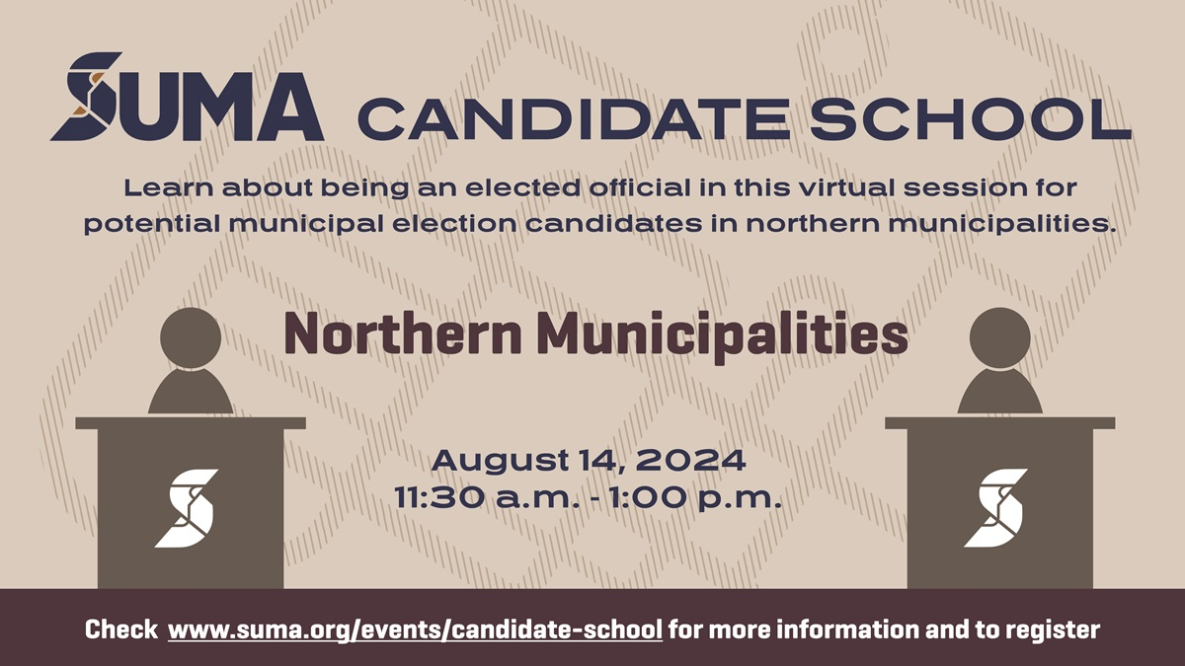
Image:

Facebook and LinkedIn:
Do you have an interest in municipal politics? Have you thought about running for municipal council? Join a free virtual session hosted by SUMA on August 14 to learn about being on municipal council in a northern municipality. Hear what the role of council is, what your responsibilities are as a councillor, and more. The session will include a virtual “Northern Municipal Hall” where you can ask your municipal governance questions. Visit www.suma.org/events/candidate-school to learn more and to register.

Twitter:
Do you have an interest in municipal politics? Have you thought about running for municipal council? Join a free virtual session hosted by @SUMAconnect on August 14 to learn about being on municipal council in a northern municipality. Learn more at www.suma.org/events/candidate-school

