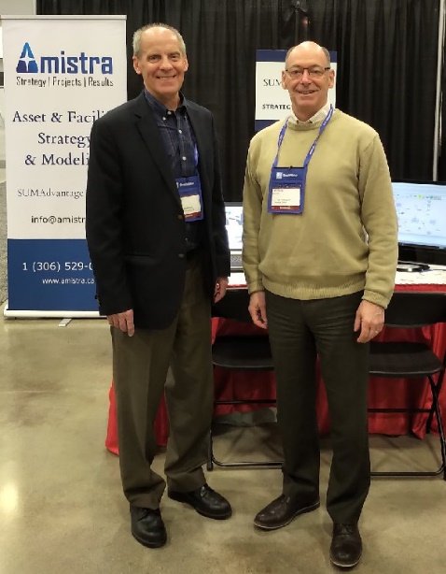
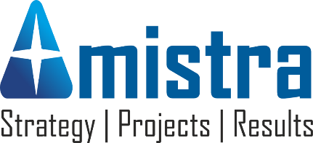
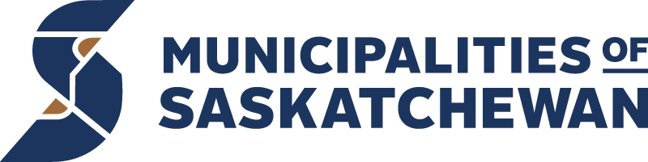
Municipal asset management has never been so complex – or so necessary. We understand the challenges of creating and implementing asset strategies when ‘keeping the lights on’ is the top priority.
Strategic Partner
We are
Amistra Consulting
and
EMS Croscan
We provide the full range of asset & facility management services, from advisory to implementation. We specialize in developing model-driven strategies
to implement your municipal master plans.
We are experts in project management and stakeholder consultation.
We are Professional Engineers and Certified Management Consultants, with expertise that also includes developing business cases, feasibility studies, grants & proposals, studies and other reports.
Your plan - better™
Amistra & EMS Croscan
SPR Momentum – Your plan… better™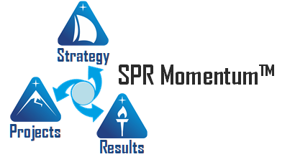
Al Thibeault (right) and Dan Kishchuk (left) have over 75 years of planning experience. Our practical approach means you won’t be starting over, and you won’t be sacrificing service priorities for elusive future benefits. Instead, we fold your plans and priorities into a model-driven planning approach to get you on a strategic path sooner than expected.
Quite simply – we work with you so that the result is
“The Right Plan – Right Now.™”.

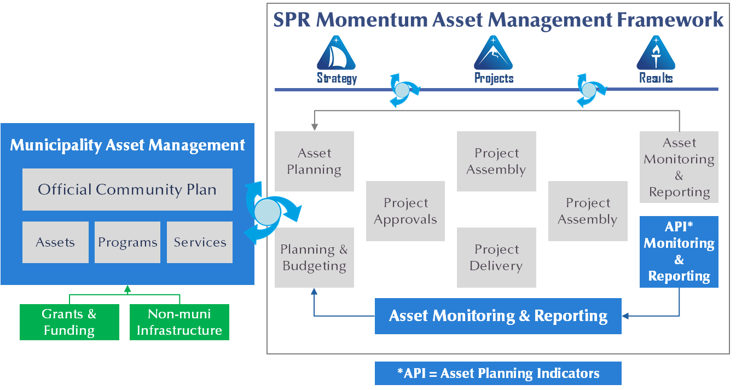
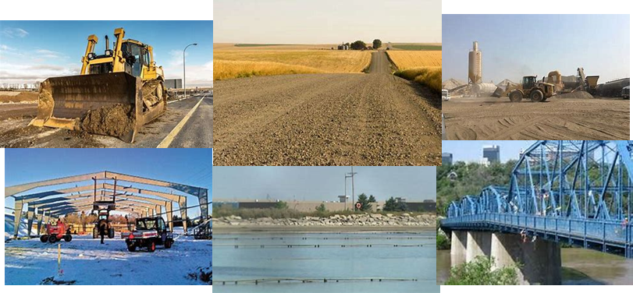
As pre-approved Municipalities of Saskatchewan Central Source
strategic partners we are just one click away from serving you.
Click https://www.vendorpanel.ca/ today!
For more information email us at info@amistra.ca
Our Asset Management Framework builds strategic planning into the asset lifecycle for all asset classes and integrates with the municipality master plan.
The Right Plan – Right Now™

